|  |  |
| --- | --- |
|  | LOGO UniPartner |
|  |  |
|  | |

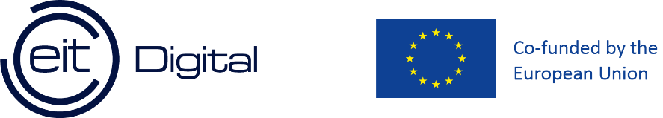

Master’s Degree in

……………………………

FINAL DISSERTATION

[TITLE]

Subtitle (*optional*)

|  |  |
| --- | --- |
| SupervisorUniTrento | SupervisorUniPartner (*Optional*) |
| (Name, Surname and signature) | (Name, Surname and signature) |
|  |  |
|  |  |
| Student |  |
| (Name, Surname and ID number) |  |
|  |  |
| ACADEMIC YEAR _______/_______ | |