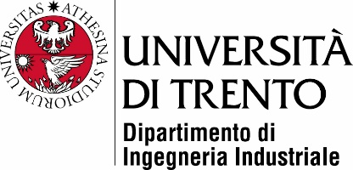

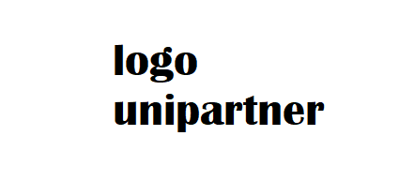

*(ONLY FOR EIT STUDENTS)*

Master’s Degree in

Mechatronics Engineering

FINAL DISSERTATION

[TITLE]

Subtitle (optional)

|  |  |
| --- | --- |
| SupervisorUniTrento | *SupervisorUniPartner |
| (Name, Surname and signature) | (Name, Surname and signature) |
|  |  |
|  |  |
| Student |  |
| (Name, Surname and ID number) |  |
|  |  |
|  | |

ACADEMIC YEAR 2019/2020