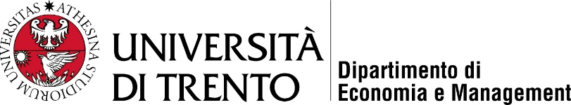 | 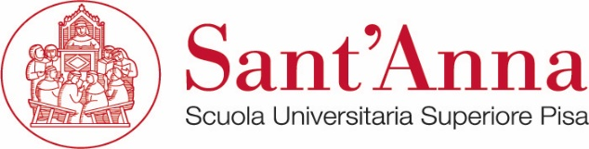

MAIN - Master in Innovation Management
(Laurea Magistrale)

Master Thesis

title in capital letters

Supervisor: Student:
Prof.

Academic Year

